Creative Coding 2
Statistics
Measures of Location and Dispersion
Introduction:
In this lecture we will look at the topics of mean and standard deviation, and the related areas of median, mode, range and quartile deviation.

Formulae:

Mean:
$$\overline{x}=\frac{\sum{x}}{N}$$

Standard Deviation:

$$s^{2}=\frac{\sum_{i=1}^{n}{{x_{i}}^{2}-{[(\sum_{i=1}^{n}{x_{i})}}^{2}/n]}}{n-1}$$

Quartile Deviation:
$$\frac{Q_{3}-Q_{1}}{2}$$

The Summation Symbol ∑ (sigma):
The summation symbol, ∑, is a useful shorthand notation for representing the addition of numbers.

Example:
The addition of the following four numbers:
5, 8, 3, 30 can be written as:
5 + 8 + 3 + 30 = 46

However if we represent the four numbers as x₁, x₂, x₃ and x₄ we can represent the addition in a more general way as:
x₁ + x₂ + x₃ + x₄ = 46
The above summation can be more concisely represented using:
$$\sum_{i=1}^{4}{x_{i}}$$

which sums the four data points, x₁, x₂, x₃ and x_{4.}

More generally to add up n numbers we use the notation: $$\sum_{i=1}^{n}{x_{i}}$$

The Sum of Squares:
The sum of squares represented as: $$\sum_{i=1}^{n}{{x_{i}}^{2}}$$
is calculated by first squaring each data value and then adding the squared numbers.

Example:
Calculate the sum of the squares of the four numbers 5, 10, 4, 20.
Solution: (5)² + (10)² + (4)² + (20)² = 25 + 100 + 16 + 400 = 541

The Total Squared:
The total squared is calculated by first adding up the numbers in a list and then squaring the total. It is denoted by:

$${\left(\sum_{i=1}^{n}{x_{i}}\right)}^{2}$$

Note the brackets around the summation symbol.

Example:
To calculate the total squared for 5, 10, 4 and 20, we just add the numbers and square the total of 39. i.e. 5 + 10 + 4 + 20 = 39. Then we get (39)² which is equal to 1521.

Note: It is important to distinguish between the Sum of Squares and the Total Squared. The Total Squared will have brackets around the summation symbol.

The Cross Product:
The cross product is represented by:$$\sum_{i=1}^{n}{x_{i}}y_{i}$$
Example:
Given 2 lists of numbers say:
5, 10, 4 and 20 and 2, 3, 8, and 6.
If we represent the first list as x₁, x₂, x₃ and x_{4,} and the second list as y₁, y₂, y₃ and y_{4,} then the cross product is calculated by multiplying x₁ by y₁, x₂ by y₂ etc. and adding the four results.
i.e. (5*2) + (10*3) + (4*8) + (20*6) = 10 + 30 + 32 + 120 = 192.

Note: It is important to distinguish between: $$\sum_{i=1}^{n}{x_{i}}y_{i}$$
and
$$\left(\sum_{i=1}^{n}{x_{i}}\right)\left(\sum_{i=1}^{n}{y_{i}}\right)$$

Question:
Calculate $$\left(\sum_{i=1}^{n}{x_{i}}\right)\left(\sum_{i=1}^{n}{y_{i}}\right)$$

for the 2 lists of numbers, 5, 10, 4 and 20 and 2, 3, 8, and 6.
from the example above.

Solution:
This is calculated by multiplying the total of the two data sets i.e.
5 + 10 + 4 + 20 = 39
2 + 3 + 8 + 6 = 19
Therefore $$\left(\sum_{i=1}^{n}{x_{i}}\right)\left(\sum_{i=1}^{n}{y_{i}}\right)=\left(39\right)\left(19\right)=741$$

Compare with the cross product solution of 192 which is shown on the previous page.

Exercises 1:
- The following data represents hours per day spent on Social Media for a group of 5 5th year 2nd level students.
2, 1, 0.5, 3, 0.
- $\sum_{i=1}^{n}{x_{i}}$
- $\sum_{i=1}^{n}{{x_{i}}^{2}}$
- ${\left(\sum_{i=1}^{n}{x_{i}}\right)}^{2}$

Calculate (i), (ii) and (iii) for this data.

- The current, I in a circuit is measured for various values of applied voltage V volts as shown below:

Current (X) | 41.1 | 55.6 | 65.8 | 81.6 | 105 | 127
Voltage (Y) | 8 | 12 | 15 | 20 | 28 | 36

If we denote current as X and voltage as Y, calculate the following for this data set:

$$(i)\sum_{i=1}^{n}{x_{i}}$$

$$(ii)\sum_{i=1}^{n}{y_{i}}$$
$$(iii)\sum_{i=1}^{n}{{x_{i}}^{2}}$$

$$(iv)\sum_{i=1}^{n}{{y_{i}}^{2}}$$

$${(v)\left(\sum_{i=1}^{n}{x_{i}}\right)}^{2}$$
$${(vi)\left(\sum_{i=1}^{n}{y_{i}}\right)}^{2}$$

$$(vii)\sum_{i=1}^{n}{x_{i}}y_{i}$$

$$(viii)\left(\sum_{i=1}^{n}{x_{i}}\right)\left(\sum_{i=1}^{n}{y_{i}}\right)$$

Summarising information:
Having collected information, it is important to be able to present the results in a manner that allows the main features of the data to be understood readily. For example a data set showing overtime hours worked per month by 100 employees in a particular factory might best be presented by giving one number which indicates the average overtime hours worked. In addition it is often useful to provide a measure of the variability of the set of data.

In the following section we will look at techniques to calculate indicators of average and variability in data.

Measures of location:
Measures of location are known as averages for a set of data. They are single values intended to represent a set of data.

Example: When a company quotes the number of hits on its Web page as 540 per day, it is saying that the average number over a certain number of days was 540.
There are many different averages; three of the most common and the ones we will deal with first are:
- Arithmetic mean
- Median
- Mode

Arithmetic mean:
This is more commonly known as the mean. The arithmetic mean of a set of values is defined as the sum of the values divided by the number of values.
It will be necessary to be able to calculate the mean of data presented in the form of raw data.

EXCEL: The function we will use in excel to calculate the mean is the AVERAGE function.

Mean of a set of raw data:
Suppose the sales of a computer game over 6 successive days were 6, 8, 19, 12, 17 and 8. What is the mean number of copies of the game sold per day?
If we label the values x₁ = 6, x₂ = 8, x₃ = 19, x₄ = 12, x₅ = 17, x₆ = 8.

Mean = x₁+x₂+x₃+x₄+x₅+x₆ = Sum = $\sum_{i=1}^{6}{x_{i}}$
6 Size

Mean = Total of Values divided by Number of Values
= (6 + 8 + 19 + 12 + 17 + 8)/6
= 70/6 = 11.67

The median:
The median is generally considered as an alternative to the mean as a measure of average.
Suppose a machine produces 5, 3, 5, 21 and 2 defective circuit-boards over a 5 day period. The mean is 7.2 which is unrepresentative of the values. In cases like this we use another measure of average; namely the median.

The median of a set of data is the value of that item which lies halfway along the set when arranged in size order. It is found by placing the values in size order (ranking the values from lowest to highest) and picking the middle value as the average. It is located in position (n+1)/2.

For the machine producing circuit boards the values in order are:
2, 3, 5, 5, 21. The median is in position (5+1)/2 = 3. The median is 5.

Note that when a set of data contains an even number of items, there is no unique middle value. In this case we get the mean of the two middle values

Examples:
1. Find the median of 43, 75, 48, 51, 51, 47 and 50.

Written in size order the values are 43, 47, 48, 50, 51, 51, 75 with the middle value equal to 50.

2. Find the median of 2, 4, 6, 1, 2, 3, 3, and 2.

Written in size order the values are 1, 2, 2, 2, 3, 3, 4, 6. There is an even number of values (8). The two middle values are 2 and 3. The median is the mean of these two values which is (2+3)/2 = 2.5

EXCEL: In Excel we use the MEDIAN function to calculate the median of a set of values.

The mode:
The mode of a set of data is the value that occurs most often in the data set.

Example: If a shop sold television sets, the answer to the question “What price does the average television set sell at”? is probably best given as the price of the best-selling television. This value is the mode.

Note: A set of data which has a single mode is called unimodal, one which has two modes is bimodal, and one with more than two modes is multi-modal

The mode of the set 2, 1, 3, 2, 1, 3, 4, 1 is 1 since this occurs most often.

EXCEL: The MODE function is used in Excel for this calculation.

Choice of Average:
It is sometimes difficult to know which average should be used in a given situation.
- Essentially, if we wish to know the result that would follow from an equal distribution of the values, then the mean is the most suitable.

- The median is often a better measure of average or central tendency than the mean if there are extreme values in a data set. For example if the wages of 9 employees in a firm are €7000, €9000, €10000, €12000, €13000, €15000, €20000, €25000 and €50000 p.a. the mean wage is about €18000, while the median wage is €13000. In this case the median value is more a more representative measure of the average wage than the mean value of €18000.

- If the most typical value is required then the mode is the most appropriate.

Measures of Dispersion:
Dispersion is the statistical name for the spread or variability of data. Measures of dispersion describe how spread out or scattered a set or distribution of numeric data is. The most important measures are the:
- Range
- Variance (s²) and Standard Deviation (s)
- Interquartile Range (IQR) and Quartile deviation

For example the two data sets (i) and (ii) both have the same mean of 28.

- 26, 27, 28, 29, 30
- 5, 19, 20, 36, 60

However the data sets are very different. In the first data set the data ranges from 26 to 30 while for the second data set the values range from 5 to 60. The fact that both data sets have the same mean tells very little about the data unless we also consider the variation or spread of data in the set.

Another example of two data sets with the same mean is represented by the histograms shown below. The data sets from which the histograms were computed both have the same mean of 28, but the data set represented by the left histogram is less variable with its data values more tightly packed around the mean compared with the right histogram.
This can be seen if we look at the x-axis range of the two histograms. The histogram on the left suggests that the data ranges from about 25 to 31 whereas for right histogram, the data ranges from about 10 to 45.
We therefore need to compute measures of variation if we are to gain a fuller understanding of our data.
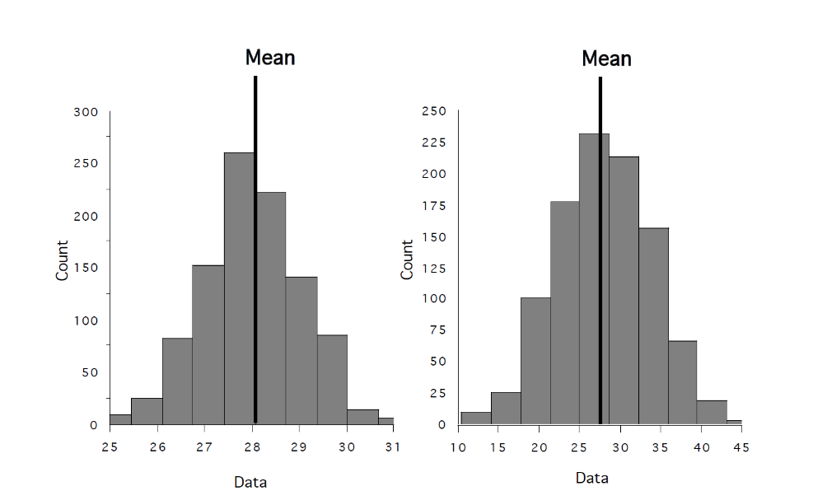
Range:
The most basic way of showing the measure of variability in a data set is by using the range. The range is defined as the difference between the smallest and largest values of the items in a set or distribution.
One disadvantage of the range is that it uses only the highest and lowest values in the data set while ignoring information held in the remaining values. Its main advantage is its simplicity of calculation.

Example: Find the range for the following data describing the number of rejected circuit boards found from the output of two separate machines over 6 days.
Machine 1: 4, 7, 2, 1, 6, 4
Machine 2: 4, 4, 3, 4, 5, 4

The range of values for Machine 1 is 7-1 = 6 rejects.
The range of values for Machine 2 is 5-3 = 2 rejects.
Thus the daily production of reject circuit boards is more variable for machine 1 than for machine 2, even though they produce the same mean number of rejects (4).

EXCEL: The range is calculated in Excel as the maximum (MAX) minus the minimum (MIN).

Standard deviation:
This is the most commonly used measure of dispersion.

Variance:
The variance s² takes into account the distance of each data value in the sample from the sample average, and is calculated using the following formula:

$$s^{2}=\frac{\sum_{i=1}^{n}{{x_{i}}^{2}-{[(\sum_{i=1}^{n}{x_{i})}}^{2}/n]}}{n-1}$$

where n is the number of data values.

Standard deviation:
The square root of the variance is the standard deviation.

Example:
Find the mean and standard deviation of the set of numbers: 3, 6, 7, 8, 11, 13.
Step 1: The mean is (3+6+7+8+11+13)/6 = 48/6 = 8.

Step 2: 9 + 36 + 49 + 64 + 121 + 169 = 448.

Step 3: (48)²/6 = 384.

Step 4: The variance is calculated using the formula for s².

$s^{2}=\frac{\sum_{i=1}^{n}{{x_{i}}^{2}-{[(\sum_{i=1}^{n}{x_{i})}}^{2}/n]}}{n-1}$ = 448 – 384 = 12.8
5

Step 5: The standard deviation is $\sqrt{12.8}=3.6$ rounded to one decimal place.

A note on samples:
Strictly speaking we should use the term sample mean or sample standard deviation as we are assuming the data set is a sample from a much larger data set. For example, the wages of the wages of the 9 employees in the earlier example are a sample of 9 from the whole workforce. If we are not dealing with a sample but with all the data (the population of data), the formula for the standard deviation changes slightly. Instead of a denominator n-1 we have a denominator n in the formula. The symbol used is σ (small sigma) instead of s.

Example: Calculate the standard deviation in the number of defective circuit boards produced each day by a machine which outputted 4, 7, 2, 1, 6 and 4 defective circuit boards over 6 days.

Step 1: Calculate the mean = $\overline{x}=$ 24/6 = 4.

Step 2: 16 + 49 + 4 + 1 + 36 + 16 = 122.

Step 3: (24)²/6 = 96.

Step 4: s² = 122 – 96 = 5.2.
5
Step 5: Therefore standard deviation = SD = 2.28 circuit boards.

EXCEL: The function STDEVP is used to calculate the standard deviation of a set of data in Excel.

Skewness
In addition to measures of average and variability of a data set it is often useful to characterise the overall shape or distribution of the data. In this context we define a data set as symmetric or skewed.

A symmetric data set implies that one half of the distribution is the same as the other half. The most common symmetric data set has a normal or bell shaped profile – example below.

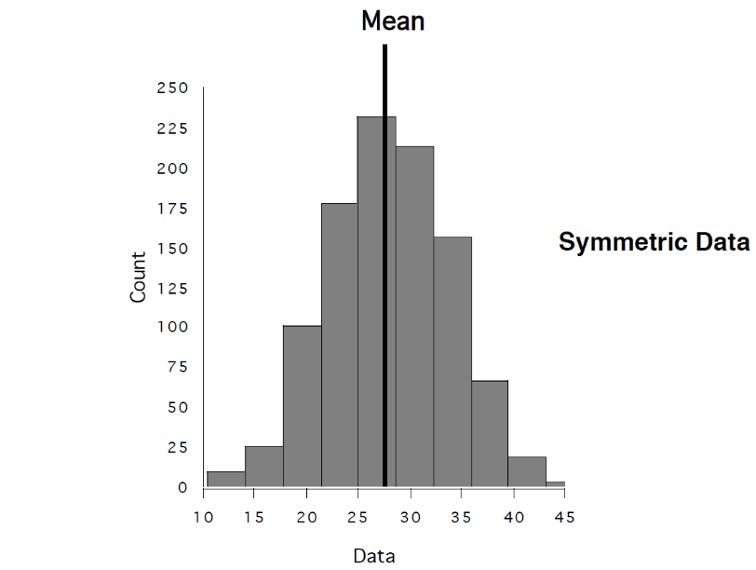
For a symmetric data set the mean, median and the mode are approximately equal. The normal distribution is one of the most common shapes for data, and describes a wide range of natural phenomenon, for example, the weights, heights and IQ levels of populations.

Skewed data on the other hand are not symmetric and are characterised by the presence of a long tail in the plotted data. If the tail is to the left hand side of the plot we say the data set is negatively skewed, whereas if the tail is on the right hand side we describe the data set as positively skewed. For skewed data, the median is a more appropriate measure of average than the mean as the presence of a relatively small number of large data values can distort the average by dragging it away from the centre of the data as we saw in the ‘wages of 9 employees’ earlier example.

Examples:
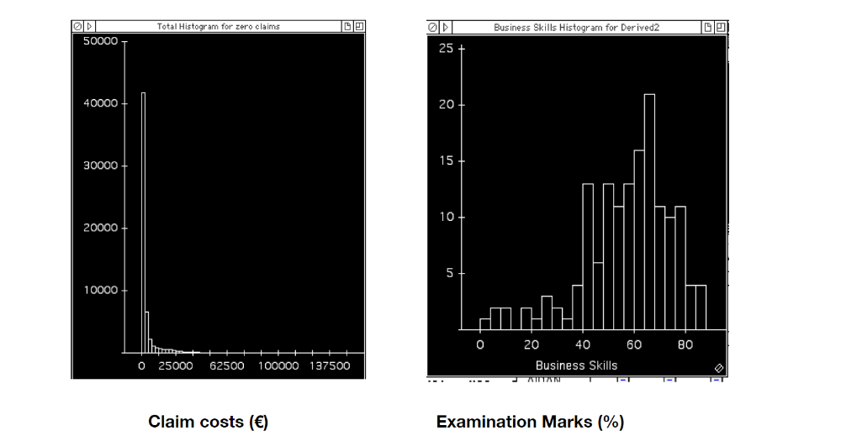

The (left) plot is an example of a positively skewed data set. The data is based on the claim costs for a sample of road accidents in Ireland in 2014. The majority of claims are under €1000, but there are a small number of very large claim costs which produce the right hand tail in the plot. The median claim for this data set is €1000, compared with a mean claim of €5000. The median is a better measure of average claim cost for this skewed data set as it is a better reflection of the average claim cost.

The (right) plot is an example of a negatively skewed distribution. The data set is based on the exam results for a module in IADT between the years 2007 and 2012. In this example the median score of 60% is higher than the mean score of 55% as the low scores drag the mean down. Again the median of 60% is a better reflection of the average exam result due to the skewness of the exam results.

Quantiles:
A quantile is the name given to an item that lies at some proportional way along a size ordered set or distribution.

Quantiles are normally considered in groups, the members of which split up a size ordered set into equal portions.

The median lies in the middle of a size ordered set of data, hence it splits a size ordered set in half; this is a particular example of a quantile.

Interquartile range (IQR)
A size ordered set can be split into 4 equal parts. The 3 values that do this, lying one quarter, one-half and 3 quarters way along the set are known as quartiles.

The point one quarter way along a set is known as the lower quartile (Q₁) which has one quarter of the values below it.
The point three quarters way along a data set is known as the upper quartile (Q₃); this has three quarters of the values below it.
The point two quarters of the way along a data set is called the median.

The interquartile range is the difference between the upper and lower quartiles of a data set. This statistic tells us the range of values that encompass 75% of the data set.

Example:
In a previous data set the wages of 9 employees (in size order) were as follows:
€7000, €9000, €10000, €12000, €13000, €15000, €20000, €25000 and €50000 p.a.
The median was calculated as €13000.

The lower quartile is calculated by finding the median of the data values below and including the median of €13000. i.e.
€7000, €9000, €10000, €12000, €13000
Therefore the median of these 5 points, €10000, is the lower quartile.

In a similar way the upper quartile is calculated by taking the values above and including the median i.e.
€13000, €15000, €20000, €25000, €50000
Therefore the median of these 5 points, €20000, is the upper quartile.

The interquartile range is: 20000 – 10000 = 10000. Normally when the median is used as an average measure, the range or the IQR is used to measure the variation.

Quartile deviation:
When we have the values of the lower and upper quartiles we can calculate the measure of dispersion called the quartile deviation.
The quartile deviation is given by:
Quartile deviation = Upper quartile – Lower quartile = Q₃ – Q₁
2 2

Or IQR
2

Example 1:
Find the lower and upper quartile and the quartile deviation for the following raw data describing the number of students attending class over 8 days.
6, 8, 3, 3, 5, 7, 10, 4.

Step 1: Place the data in size order and find the median.
3, 3, 4, 5, 6, 7, 8, 10.

There are 8 values so the median is the average of the 4th and the 5th value which is (5+6)/2 = 5.5.

Step 2: Find the lower quartile by looking at the values below the median and finding the middle of these values; the middle of the values 3, 3, 4, 5, is
Q₁ = 3.5.

Step 3: Find the upper quartile by looking at the values above the median and finding the middle of the values; the middle of the values 6, 7, 8, 10, is
Q₃ = 7.5.

Step 4: Calculate the quartile deviation = Q₃ – Q₁ = 7.5 – 3.5 = 2 students.
2 2

Example 2:
Find the lower and upper quartile and the quartile deviation for the following raw data describing the number of students attending class over 9 days.
4, 10, 10, 2, 3, 5, 6, 4, 9.

Step 1: Place the data in size order and find the median.
2, 3, 4, 4, 5, 6, 9, 10, 10,
There are 9 values so the median is the 5th value which is 5.

Step 2: Find the lower quartile by looking at the values below the median (including the median) and finding the middle of these values; the middle of the values 2, 3, 4, 4, 5 is Q₁ = 4.

Step 3: Find the upper quartile by looking at the values above the median (including the median) and finding the middle of these values; the middle of the values 5, 6, 9, 10, 10 is Q₃ = 9.

Step 4: Calculate the quartile deviation = Q₃ – Q₁ = 9 – 4 = 2.5 students.
2 2

Other quantiles:
Deciles:
These are nine points of a distribution which divide it into 10 equal parts. The 2nd decile would be the point below which 2 tenths (20%) of the values lie.

Percentiles:
These are the ninety nine points that divide a distribution into 100 equal parts. the 23rd percentile would be the point below which 23% of the values lie.

Exercises 2:
1. Find the mean, median and mode of the following data set describing the number of products sold through an internet retail site.
3, 4, 7, 2, 1, 8, 5, 5, 10.

2. Find the mean, median and mode of the following data set describing the length of time in hours between discovery of bugs during final testing of a second piece of software.
14, 9, 6, 12, 6, 4, 8, 4, 7, 9.

3. The number of web pages developed by 5 employees of a firm yesterday is presented below. Find the mean, median and mode number of pages developed per employee.

Employee | A | B | C | D | E
No. of pages | 2 | 3 | 1 | 7 | 2

4. Find the range, s.d., and quartile deviation of the following data set describing the length of time in hours between discovery of bugs during final testing of a piece of software.
3, 4, 7, 2, 1, 8, 5, 5, 10.

5. Find the range, s.d. and quartile deviation of the following data set describing the length of time in hours between discovery of bugs during final testing of a second piece of software.
14, 9, 6, 12, 6, 4, 8, 4, 7, 9.

